**Self-Learning Bot (Medic Bot)**

**Mr Muthuraju V1, Ambrish Kumar. S2, S. Mohammed Enthihaj3, Rihan Anwar CA4, Krishnan S 5**

*1Asstistant Professor, School of CSE, Presidency University, Bangalore, India.*

*2,3,4,5B. Tech Final Year Students, Computer Engineering (Artificial Intelligence and Machine Learning), Presidency University, Bangalore, India.*

muthuraju.v@presidency.com, kumarambrish248@gmail.com, Mohammedimthihyaz@gmail.com,

rihanrichi@gmail.com, krishnan.spu@gmail.com

# *Abstract*

In the field of healthcare innovation, our team has developed a Medic Bot, seamlessly integrating Reinforcement Learning and Natural Language Processing (NLP) to enhance the user experience in medical assistance. This innovative system is designed to provide users with an interactive and personalized healthcare platform, encouraging individuals to partake in meaningful conversations promotes originality in their discussions, seek medical guidance, and receive tailored recommendations. Through the application of Reinforcement Learning, the Medic Bot continually refines its responses based on user feedback and interactions, ensuring a dynamic learning process that adapts to evolving user needs.

Natural Language Processing forms the foundation of the Medic Bot's ability to comprehend and respond to user queries with human-like understanding, creating a more intuitive and accessible interaction. The system incorporates advanced machine learning algorithms to classify intents, extract key medical entities, and generate responses that align with the intricacies of natural language. By navigating through medical literature, research papers, and clinical notes, the Medic Bot establishes a robust knowledge base, providing users with accurate and relevant medical information.

This inventive fusion of Reinforcement Learning and NLP not only represents a significant advancement in healthcare technology but also emphasizes continuous learning and improvement. The Medic Bot's capacity to learn from user feedback, coupled with its commitment to staying informed through iterative development, positions it as a dynamic and reliable healthcare companion. This abstract authentically captures the essence of our Medic Bot, symbolizing a transformative step toward a future where healthcare interactions are not only informative but also conversational and usercentric.

***Keywords***— **NLP, Reinforcement Learning, KNN, TF-IDF,**

**SVM, cosine similarity, deep learning**

# I. INTRODUCTION

The topic "Self-Learning Bot in the Medical Sector" explores the application of chatbots and natural language processing (NLP) in healthcare. It delves into the creation of conversational chatbots designed to engage with elderly individuals, track health trends, and deliver fundamental health information. The document discusses the incorporation of machine learning algorithms, specifically KNN, for evaluating symptoms and the integration of external APIs to enhance NLP capabilities. It emphasizes the pivotal role of these technologies in automating user communication and providing crucial health information.

Furthermore, the topic explains on the processes of data collection, feature extraction, and system testing. It also highlights the potential of chatbots to streamline healthcare processes, saving both time and money also underscores the broad and optimal experiences that chatbots can offer across diverse applications. It ultimately emphasizes the transformative impact of NLP-powered chatbots on the medical sector, enhancing patient care and accessibility to vital medical information.

The use of chatbots and natural language processing (NLP) in healthcare has received great attention in recent years. With the demand for healthcare services increasing and the number of doctors decreasing, chatbots have emerged as a promising way to provide advice and assistance to patients. These chatbots can interact with patients by analyzing their symptoms, and provide appropriate medical advice. The "Active language bots in healthcare" provides information on the development and use of chatbots in healthcare. The article also introduces machine learning algorithms such as KNN for symptom analysis and integration of NLP external APIs. Additionally, the article underscores the significance of acknowledging and valuing meaningful conversations ,collecting data and disseminating results in the development of effective chatbots. It also discusses software and database testing procedures and backup procedures. Aside from chatbots' benefits in saving clinical time and money, their ability to deliver comprehensive information and insights across multiple applications is also important. Overall, this article provides insight into the development and use of chatbots in healthcare and highlights the role NLP-powered chatbots can play to support patient care and access to medical information. healthcare Industry.

# II. METHODOLOGY

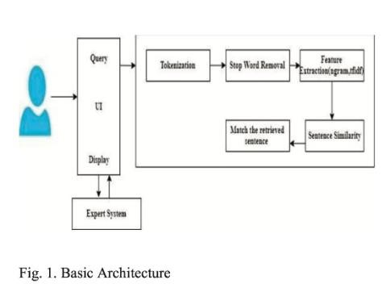

**Data Collection and Preparation:**

Collect a diverse dataset comprising medical literature, research papers, clinical notes, and publicly available healthcare information to establish the foundational knowledge of the chatbot***.***

Preprocess the data through cleaning and standardizing the text. Remove irrelevant information and structure the data in a format suitable for analysis and modelling.

**Natural Language Processing (NLP):**

Implement NLP techniques for parsing and comprehending medical text. This includes tokenization, stop-word removal, stemming, and lemmatization.

Utilize named entity recognition (NER) and part-ofspeech tagging to identify medical entities, relationships, and categories within the text.

**Machine Learning and Deep Learning Models:**

Develop machine learning models, such as support vector machines (SVM) or decision trees, to classify intents and extract key medical entities from user queries.

Explore advanced deep learning models like recurrent neural networks (RNNs) or transformers for intent classification, entity recognition, and response generation based on pre-processed medical text***.***

**Reinforcement Learning and Feedback Loop:**

Implement a reinforcement learning approach to continually enhance the chatbot's responses based on user feedback and interactions.

Create a feedback loop enabling users to rate and provide feedback on the chatbot's responses. This allows the model to learn from mistakes, improving its accuracy and relevance over time***.***

**Iterative Development and Evaluation:**

Adopt an iterative development approach, continuously updating, refining, and expanding the chatbot with new medical data and improved algorithms.

Evaluate the chatbot's performance using metrics like precision, recall, F1-score, and user satisfaction surveys. Identify areas for enhancement to ensure the chatbot meets its intended objectives

# III SYSTEM DESIGN

## Introduction of Input Design

***A.*** The development process outlined in the document titled "Self-Learning Bot (Medic Bot)” incorporates several essential components, including a discussion director, a knowledge base, and an external API for Natural Language Processing (NLP). The discussion director serves as the fundamental element of the chatbot, managing the flow of communication between the user (stoner) and chatbot. It employs an external NLP API to analyse text, identify patterns in language, and decipher specific word meanings. ***B.*** Additionally, the discussion director utilizes the knowledge base to formulate user queries and cross-verify them against the chatbot's stored information. Techniques such as TF-IDF, cosine similarity, and N-gram similarity are employed to establish content relevance and assess the similarity of judgments.

***C.*** The knowledge base functions as a structured database storing information relevant to the chatbot in a schema format. If the desired information is not present in the database, the system resorts to consulting experts to provide answers. External APIs for NLP are integrated into the system to tokenize and process text, revealing interpretations and meanings of particular words. The chatbot also employs machine learning algorithms, such as Knearest neighbours (KNN), for symptom analysis. Additionally, other NLP APIs are incorporated for various linguistic tasks.

## A. Objectives for Input Design

The proposed objectives for the chatbot system are:

-

1. Providing a validated and interactive healthcare interface that enables users to pose queries, share relevant medical information, and receive recommendations from the chatbot.
2. Utilizing Natural Language Processing (NLP) and machine learning algorithms to comprehend natural language, facilitating automated user communication.
3. Integrating external NLP APIs to analyse textual data, uncovering sentence structures, and providing insights into the meanings of specific words.
4. Implementing a knowledge base to organize user queries and cross-referencing them with the chatbot's information repository.
5. Employing techniques such as TF-IDF, cosine similarity, and N-gram similarity to evaluate keyword importance and assess the similarity of sentence structures.
6. Developing the system using the Java programming language to create visually appealing interfaces.
7. Utilizing a Relational Database Management System (RDBMS) to store input query data for analysing communication patterns.
8. Empowering users to track blood pressure trends and receive alerts or healthcare advice from the chatbot to assist or alleviate specific conditions.
9. Offering a comprehensive healthcare experience by integrating features such as sentence structuring capabilities, a conversation director, a knowledge base, and theoretical elements through external APIs.
10. Emphasizing the importance of data collection and accuracy in the development of effective chatbots, enhancing the reliability and sensitivity of the chatbot's responses.

## Output Design

The process of designing an output is a crucial aspect of any system. During this phase, developers identify the types of tasks required and carefully consider the

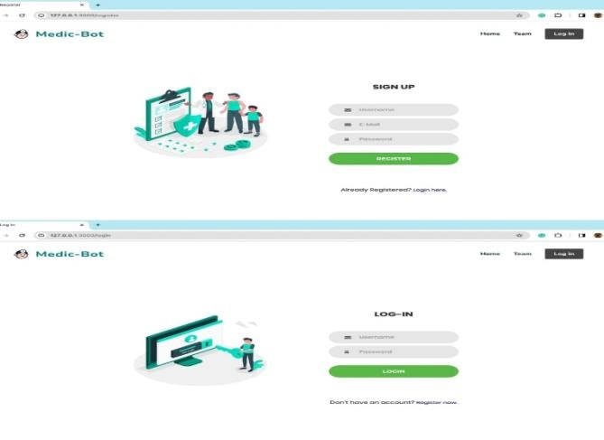necessary controls and prototype layouts for the affair.

## B. Objectives for Output Design

1. Incorporates Natural Language Processing (NLP) and machine learning algorithms to effectively understand user queries.
2. Provides conversational and personalized reply that simulate interactions with a genuine healthcare professional.
3. Organizes user queries by utilizing a knowledge base and cross-referencing them with the chatbot's extensive knowledge repository.
4. 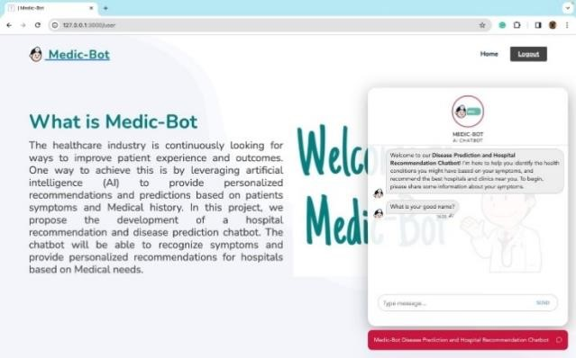Utilizes advanced mechanisms such as TF-IDF, cosine similarity, and N-gram similarity to **Fig. 2 Register and login Page** evaluate keyword importance and assess the similarity of language patterns for improved accuracy.
5. Presents responses in a user-friendly interface, incorporating text, images, or links to external sources for a comprehensive user experience.
6. Leverages external APIs for NLP to meticulously analyse text, uncovering language structures, and providing insights into the meanings of unique words.
7. Offers follow-up questions or feedback given by the user's responses, enhancing the depth **Fig.3 Result 1** and interactivity of the healthcare experience.

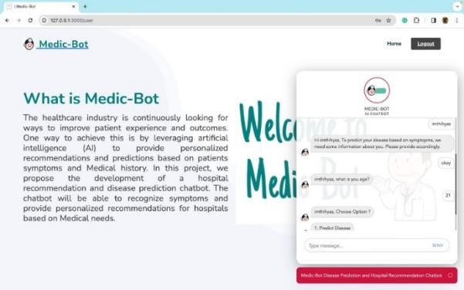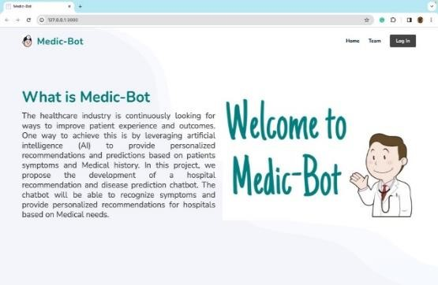**IV RESULT AND DISCUSSION**

**Fig.4 Result2**

## V Future Work

The document " Self-Learning Bot (Medic Bot)" " outlines several promising directions for future exploration and development in the field of healthcare-oriented chatbots. One notable avenue involves the integration of advanced machine learning algorithms to significantly improve the accuracy and reliability of the chatbot's responses, offering a substantial opportunity for overall functional enhancement. Another significant proposition suggests the expansion of dedicated external APIs for Natural Language Processing (NLP), thereby strengthening the chatbot's ability to comprehend natural language and enhance user interactions.

Furthermore, the document advocates for the cultivation of a more extensive knowledge base, a strategic move that empowers the chatbot to provide users with more comprehensive and accurate medical insights and recommendations. Beyond basic conversational capabilities, the envisioned evolution of healthcare chatbots extends to include remote monitoring of users' health conditions, facilitating the delivery of well-founded health recommendations based on collected data.

The document highlights the implicit integration of chatbots with Electronic Health Records (EHRs) to facilitate seamless communication among users, healthcare providers, and the chatbot, thereby streamlining the flow of critical information. The addition of internal health support and comforting services is acknowledged as an essential improvement, acknowledging the holistic nature of healthcare. Additionally, the document underscores the importance of exploring ethical and legal considerations, including aspects related to data privacy, security, and liability, as integral components for the evolving landscape.

## VI Conclusions

In conclusion, the document titled "SelfLearning Bot(Medic Bot)" emphasizes the transformative potential of chatbots in reshaping the landscape of healthcare, providing users with informed and interactive healthcare guidance. The chatbot system signifies a technological advancement, employing natural language processing (NLP) and machine learning algorithms to interpret user queries and deliver relevant medical information and recommendations. What sets the chatbot's responses apart is their conversational and personalized nature, akin to interactions with a real healthcare professional.

A critical component of its operation, the chatbot relies on a knowledge base to comprehensively organize user queries, additionally utilizing external APIs for NLP to analyze texts, unravel sentence structures, and uncover intricate details about specific words. The document, adopting a forward-looking perspective, outlines various promising directions for advancing healthcare-oriented chatbots. These potential advancements include the integration of more sophisticated machine learning algorithms, the incorporation of voice recognition and speech synthesis technologies, and the exploration of wearable devices to enhance the chatbot's capabilities.

# VII ACKNOWLEDGMENT

We acknowledge the support and resources provided by Presidency University, Bangalore which have played a crucial role in facilitating the research process. The collaborative environment and access to new technologies have greatly contributed to the development and implementation of our chat bot model.

We express our gratitude to the creators and contributors of the libraries used in our project whose innovations in Self Learning Chatbot have laid the foundation for our research. Their commitment to advancing computer vision technologies has been instrumental in shaping the success of our Project.

Furthermore, we would like to thank the individuals involved in the collection and annotation of the diverse HealthCare dataset used in our experiments. Their efforts have been essential in training and evaluating the models, ensuring the robustness and generalization of our approach.

Finally, we appreciate the encouragement and guidance provided by our mentors, advisors, and colleagues throughout the research process. Their expertise and constructive feedback have played a crucial role in refining our methodology and interpreting the results.

This research would not have been possible without the collective contributions and support from the scientific community and various stakeholders. We look forward to the continued collaboration and advancements in the field of Chatbots enabled by the integration of Reinforcement Learning.

# VIII REFERENCES

1. Shali, Prashanth, Rishi G, Shriram, Assel, Naskath, (2022)'Bots using Natural Language Processing in Medical Sector' 2022 1st International Conference on

Computational Science and Technology (ICCST) | 9781- 6654-7655-3/22/$31.00 ©2022 IEEE | DOI:

10.1109/ICCST55948.2022.10040432

1. Santhosham, Prasad Sah C,(2023)'Advanced Healthcare Chat Bot Using Python'2023 2nd International Conference for Innovation in Technology (INOCON) | 979- 8-3503-2092-3/23/$31.00 ©2023 IEEE | DOI:

10.1109/INOCON57975.2023.10101239

1. Syahirah Ahmad N, Hamim Sanusi M, Helmy Abd Wahab M, Mustapha A, Abidin Sayadi Z, Zainuri

Saringat M,(2018)'Conversational Bot for Pharmacy: A Natural Language Approach' in IEEE Xplore

1. Tanmay T, Bhardway A, Sharma S,(2020)'E-Health Bot to Change the Face of Medicare' 2020 Research, Innovation, Knowledge Management and Technology

Application for Business Sustainability (INBUSH) | 9781- 7281-1769-0/20/$31.00 ©2020 IEEE | DOI:

10.1109/INBUSH46973.2020.9392125

1. Goel A, Satyam, Sharma S,(2023)'Artificial Intelligence base Healthcare Chat Bot System'2023 8th International Conference on Communication and

Electronics Systems (ICCES) | 979-8-3503-9663- 8/23/$31.00 ©2023 IEEE | DOI:

10.1109/ICCES57224.2023.10192727

1. Srivastava P, Singh N,(2020)'AUtomatized Medical Chatbot(Medibot)'2020 International Conference on Power Electronics & IoT Applications in

Renewable Energy and its Control (PARC) 978-1-7281-

6575-2/20/$31.00 ©2020 IEEE

10.1109/PARC49193.2020.236624

1. Athulya N, Jeeshna K, S J Aadithyan, U Sreelakshmi, Hairunizha Alias Nisha

Rose,(2021)'Healthcare Chatbot'9(10)| ISSN: 2320-2882

1. Alvarez J, Campos G, Enriquez V, Miranda A, Rodriguez F, Ponce H,(2018)'Nurse-Bot: A Robot System Applied to Medical Assistance'2018 International Conference on Mechatronics, Electronics and

Automotive Engineering (ICMEAE)

1. R Jegadeesan, Dava Srinivas, N Umapathi, G Karthick, N Venkateswaran (2023)'Personal Healthcare Chatbot for Medical suggestions using Artificial Intelligence and Machine Learning'Section A-Research

paper

1. Shuyang Li, Prasad Majumder B, McAuley J,(2021)'Self-Supervised Bot play for Conversational

Recommendation with

Justifications'arXiv:2112.05197v1 [cs.CL] 9 Dec 2021

1. Dyyak I, Melnyk B, Melnyk N, Trokhaniak S, Drakohrust T, Svitlak I,(2021)'Using an Internet Bot to

Predict the Spread of COVID-19'2021 11th International Conference on Advanced Computer Information

Technologies (ACIT) | 978-1-6654-1854-6/21/$31.00

©2021 IEEE | DOI: 10.1109/ACIT52158.2021.9548345

1. Reshmanth P, Sushanth Chowdary p, Yogitha R, Aishwarya R,(2022)'Deployment of Medibot in Medical Field'2022 International Conference on Sustainable Computing and Data Communication Systems (ICSCDS) | 978-1-6654-7884-7/22/$31.00 ©2022 IEEE |DOI:

10.1109/ICSCDS53736.2022.9760900Dobbie, U. Frank, G. Kappel, S. W. Liddle, and H. C. Mayr, Eds. Cham,

Switzerland: Springer, 2020, pp. 207–222